**t-1**

**Agile process model**" refers to a software development approach based on iterative development. Agile methods break tasks into smaller iterations, or parts do not directly involve long term planning. Each iteration is considered as a short time "frame" in the Agile process model, which typically lasts from one to four weeks. The division of the entire project into smaller parts helps to minimize the project risk and to reduce the overall project delivery time requirements. Each iteration involves a team working through a full software development life cycle including planning, requirements analysis, design, coding, and testing before a working product is demonstrated to the client.

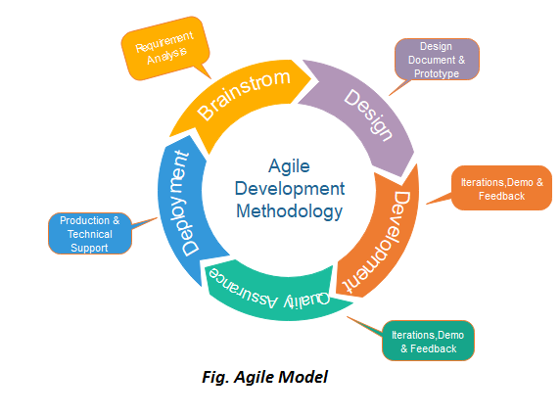

Phases of Agile Model:

Following are the phases in the Agile model are as follows:

1. Requirements gathering
2. Design the requirements
3. Construction/ iteration
4. Testing/ Quality assurance
5. Deployment
6. Feedback

**1. Requirements gathering:** In this phase, you must define the requirements. You should explain business opportunities and plan the time and effort needed to build the project. Based on this information, you can evaluate technical and economic feasibility.

Backward Skip 10sPlay VideoForward Skip 10s

**2. Design the requirements:** When you have identified the project, work with stakeholders to define requirements. You can use the user flow diagram or the high-level UML diagram to show the work of new features and show how it will apply to your existing system.

**3. Construction/ iteration:** When the team defines the requirements, the work begins. Designers and developers start working on their project, which aims to deploy a working product. The product will undergo various stages of improvement, so it includes simple, minimal functionality.

**4. Testing:** In this phase, the Quality Assurance team examines the product's performance and looks for the bug.

**5. Deployment:** In this phase, the team issues a product for the user's work environment.

**6. Feedback:** After releasing the product, the last step is feedback. In this, the team receives feedback about the product and works through the feedback.

## Agile Testing Methods:

* Scrum
* eXtreme Programming(XP)

### **Scrum**

SCRUM is an agile development process focused primarily on ways to manage tasks in team-based development conditions.

There are three roles in it, and their responsibilities are:

* **Scrum Master:** The scrum can set up the master team, arrange the meeting and remove obstacles for the process
* **Product owner:** The product owner makes the product backlog, prioritizes the delay and is responsible for the distribution of functionality on each repetition.
* **Scrum Team:** The team manages its work and organizes the work to complete the sprint or cycle.

### **eXtreme Programming(XP)**

This type of methodology is used when customers are constantly changing demands or requirements, or when they are not sure about the system's performance.

## When to use the Agile Model?

* When frequent changes are required.
* When a highly qualified and experienced team is available.
* When a customer is ready to have a meeting with a software team all the time.
* When project size is small.

## Advantage(Pros) of Agile Method:

1. Frequent Delivery
2. Face-to-Face Communication with clients.
3. Efficient design and fulfils the business requirement.
4. Anytime changes are acceptable.
5. It reduces total development time.

t-2

Extreme programming (XP) is one of the most important software development frameworks of Agile models. It is used to improve software quality and responsiveness to customer requirements. The extreme programming model recommends taking the best practices that have worked well in the past in program development projects to extreme levels.

**Good practices need to be practiced in extreme programming:** Some of the good practices that have been recognized in the extreme programming model and suggested to maximize their use are given below:

* **Code Review:** Code review detects and corrects errors efficiently. It suggests pair programming as coding and reviewing of written code carried out by a pair of programmers who switch their works between them every hour.
* **Testing:** Testing code helps to remove errors and improves its reliability. XP suggests test-driven development (TDD) to continually write and execute test cases. In the TDD approach, test cases are written even before any code is written.
* **Incremental development:**Incremental development is very good because customer feedback is gained and based on this development team comes up with new increments every few days after each iteration.
* **Simplicity:**Simplicity makes it easier to develop good quality code as well as to test and debug it.
* **Design:**Good quality design is important to develop good quality software. So, everybody should design daily.
* **Integration testing:** It helps to identify bugs at the interfaces of different functionalities. Extreme programming suggests that the developers should achieve continuous integration by building and performing integration testing several times a day.

Some of the basic activities that are followed during software development by using the XP model are given below:

* **Coding:** The concept of coding which is used in the XP model is slightly different from traditional coding. Here, the coding activity includes drawing diagrams (modeling) that will be transformed into code, scripting a web-based system, and choosing among several alternative solutions.
* **Testing:** XP model gives high importance to testing and considers it to be the primary factor to develop fault-free software.
* **Listening:** The developers need to carefully listen to the customers if they have to develop good quality software. Sometimes programmers may not have the depth knowledge of the system to be developed. So, the programmers should understand properly the functionality of the system and they have to listen to the customers.
* **Designing:** Without a proper design, a system implementation becomes too complex and very difficult to understand the solution, thus making maintenance expensive. A good design results elimination of complex dependencies within a system. So, effective use of suitable design is emphasized.
* **Feedback:** One of the most important aspects of the XP model is to gain feedback to understand the exact customer needs. Frequent contact with the customer makes the development effective.

t-3

DevOps

The words "Development" and "Operations" are used to form the term "DevOps."

Software development and operations are combined to form the term "DevOps." This enables one team to manage all stages of the lifetime of an application, from development to testing, deployment, and operations. By using DevOps, you may reduce the distance between system administrators, QA engineers, and software developers.

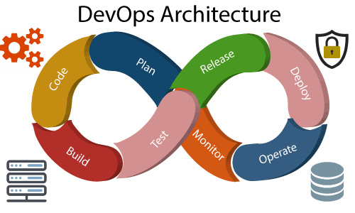

DevOps architecture is used for the applications hosted on the cloud platform and large distributed applications. Agile Development is used in the DevOps architecture so that integration and delivery can be contiguous. When the development and operations team works separately from each other, then it is time-consuming to **design, test**, and **deploy**. And if the terms are not in sync with each other, then it may cause a delay in the delivery. So DevOps enables the teams to change their shortcomings and increases productivity.

Below are the various components that are used in the DevOps architecture:

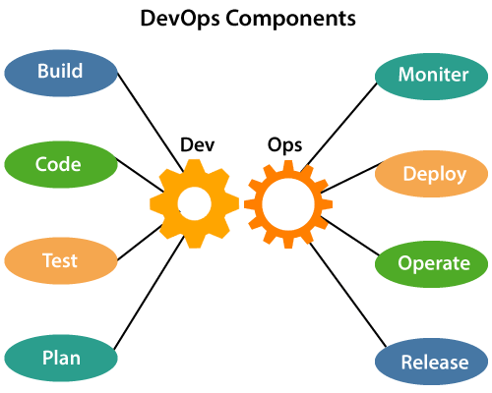

1) Build

Without DevOps, the cost of the consumption of the resources was evaluated based on the pre-defined individual usage with fixed hardware allocation. And with DevOps, the usage of cloud, sharing of resources comes into the picture, and the build is dependent upon the user's need, which is a mechanism to control the usage of resources or capacity.

2) Code

Many good practices such as Git enables the code to be used, which ensures writing the code for business, helps to track changes, getting notified about the reason behind the difference in the actual and the expected output, and if necessary reverting to the original code developed. The code can be appropriately arranged in **files, folders**, etc. And they can be reused.

3) Test

The application will be ready for production after testing. In the case of manual testing, it consumes more time in testing and moving the code to the output. The testing can be automated, which decreases the time for testing so that the time to deploy the code to production can be reduced as automating the running of the scripts will remove many manual steps.

4) Plan

DevOps use Agile methodology to plan the development. With the operations and development team in sync, it helps in organizing the work to plan accordingly to increase productivity.

5) Monitor

Continuous monitoring is used to identify any risk of failure. Also, it helps in tracking the system accurately so that the health of the application can be checked. The monitoring becomes more comfortable with services where the log data may get monitored through many third-party tools such as **Splunk**.

6) Deploy

Many systems can support the scheduler for automated deployment. The cloud management platform enables users to capture accurate insights and view the optimization scenario, analytics on trends by the deployment of dashboards.

7) Operate

DevOps changes the way traditional approach of developing and testing separately. The teams operate in a collaborative way where both the teams actively participate throughout the service lifecycle. The operation team interacts with developers, and they come up with a monitoring plan which serves the IT and business requirements.

8) Release

Deployment to an environment can be done by automation. But when the deployment is made to the production environment, it is done by manual triggering. Many processes involved in release management commonly used to do the deployment in the production environment manually to lessen the impact on the customers.

# DevOps Pipeline

A pipeline in software engineering team is a set of automated processes which allows DevOps professionals and developer to reliably and efficiently compile, build, and deploy their code to their production compute platforms.

The most common components of a pipeline in DevOps are build automation or continuous integration, test automation, and deployment automation.

A pipeline consists of a set of tools which are classified into the following categories such as:

* Source control
* Build tools
* Containerization
* Configuration management
* Monitoring

Continuous Integration Pipeline

Continuous integration (CI) is a practice in which developers can check their code into a version-controlled repository several times per day. Automated build pipelines are triggered by these checks which allows fast and easy to locate error detection.

Some significant benefits of CI are:

* Small changes are easy to integrate into large codebases.
* More comfortable for other team members to see what you have been working.
* Fewer integration issues allowing rapid code delivery.
* Bugs are identified early, making them easier to fix, resulting in less debugging work.

Continuous Delivery Pipeline

Continuous delivery (CD) is the process that allows operation engineers and developers to deliver bug fixes, features, and configuration change into production reliably, quickly, and sustainably. Continuous delivery offers the benefits of code delivery pipelines, which are carried out that can be performed on demand.

Some significant benefits of the CD are:

* Faster bug fixes and features delivery.
* CD allows the team to work on features and bug fixes in small batches, which means user feedback received much quicker. It reduces the overall time and cost of the project.

**DevOps ecosystem** is the idea that tools should be helping you in your journey from requirements to production. In order to help you along your DevOps path, we’ve categorized the different classes of tools out there.

**Scripts , CI/CD Tools , Build Tools , Source Code Management Tools (Code Repositories) , Deploy Tools /Configuration as Code ,** **Virtualization/Containerization , Reports, Statistics, and Analytics , Test Automation , Static Code Analysis Tools**